Euclidean norm

Intro

Its concept is similar to concept of Euclidean distance.

Def

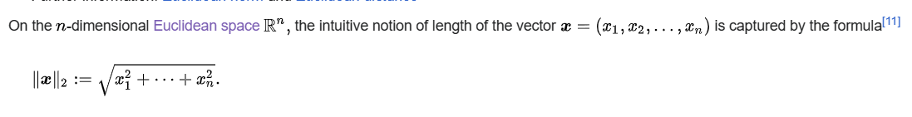

Ref

See Euclidean norm subsection in Examples section in Wiki,

[Norm (mathematics) - Wikipedia](https://en.wikipedia.org/wiki/Norm_(mathematics)#Equivalent_norms)

For more detailed explanations, see

[Euclidean space - Wikipedia](https://en.wikipedia.org/wiki/Euclidean_space#Euclidean_norm)